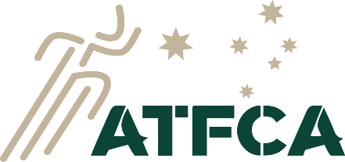
Empowering Coaches through Education
ATFCA WA BRANCH
Track and Field Coaching practical workshop
This workshop covers practical activities and correct techniques for sprints, relays, middle distance, race walking, relays, LJ, TJ, HJ, shot, discus and javelin. There are no pre-requisites for this workshop, but some familiarity with the sport will be assumed. It supplements the ATFCA online Foundation Course. The Foundation course is highly recommended and is available online: please see https://atfca.com.au/courses/foundation-course/. It is directed to the processes of coaching, with emphasis on young athletes and novice athletes. It is equivalent to completing AA’s Level 2 course. After doing the Foundation course, coaches can pursue the next course: Event Group Specialist.
Completion of the workshop earns a certificate of completion and those who do the online course as well as the workshop will be accredited as Foundation level coaches.

Saturday 23rd September 2023
(Sat: 8:20 am to 5:45 pm)
Please arrive by 8.15 am for a prompt start.
Morning and afternoon tea will be provided. BYO lunch is preferable, but shops are close by.
Venue: Ern Clark Athletics Centre, Wharf St, Cannington, WA
Cost is $160 ($30 deposit is required at time of booking. Balance due September 20th)
[ATFCA WA Branch: BSB 126 582, Account No 01044509]
(Fee includes morning and afternoon teas, presenter’s fees and venue hire)
Practical workshop includes:
○ Basic technical model, rules and drills for all athletic events (except for steeplechase, hammer throw and pole vault, which are covered in depth at the Event Group Specialist Coach Course)
○ Warm up and flexibility
The online Foundation course includes:
○ The role of the coach and the instructional process
○ Basic anatomy, physiology, biomechanics and the conditioning process
○ Basic program planning and the principles of training
○ Access to ATFCA Athletics Coaching App
Participant numbers will be limited. Please secure your place early.
Contact: atfcawa@gmail.com Anne Masters 0407470949
Please note: Workshop includes practical work. Participation is optional but recommended.

